CHAPTER THREE

METHODOLOGY

System Overview
The chapter presents the detailed methodology that is used in the design, implementation, and assessment of the Smart Energy Monitoring and Safety System. Against the backdrop of contemporary smart grid infrastructure and the growing need to financially rationalize energy consumption, this system is designed to deliver real-time high-fidelity monitoring of vital electrical parameters, namely, Root Mean Square (RMS) voltage, current, and active power. Besides, it has an independent protective system, which is aimed at alleviating the electrical faults (i.e., overvoltage, undervoltage, and overcurrent) and protecting the loads connected.
The system structural model, is a closed-loop control system model consisting of three different stages, namely: Data Acquisition (Input), Signal Processing and Control (Processing), and Feedback (Output). This approach focuses on giving a high level of reliability, accuracy of measurements, and operational safety, which follows the normal engineering approaches to embedded systems design. Figure 3.1 shows a flowchart of the system architecture and flow of signals.

Hardware Setup
The physical implementation of the model included critical choice and combination of parts in order to provide low-cost, signal fidelity, galvanic isolation, and adequacy of computational headroom. This section defines the specifications and the reason behind every hardware subsystem. These key elements are presented below and summarized in Table 3.1:
- Microcontroller Unit (MCU): ESP32 Development Board was chosen over options based on 8-bit microprocessors (e.g., Arduino Uno/Nano) because of its better 32-bit dual-core Xtensa LX6 that operates at 240 MHz. This processing ability is necessary to support continuous high-frequency sampling (required to correctly compute RMS) without preempting network stack processing. ESP32 includes an inbuilt Wi-Fi (802.11 b/g/n) to connect to the IoT, a 12-bit SAR ADC with 4096 levels of resolution (compared with 1024 of Arduino), and plenty of GPIOs to interface with peripherals.
- Voltage Sensor: The voltage transformer module used was the ZMPT101B active single-phase voltage transformer that was used to measure the AC mains voltage (220 V-240 V nominal). It uses a high-precision voltage micro-transformer to reduce the AC voltage. The sensor module has an operational amplifier circuit (LM358) to condition the signal and add a DC bias (offset) to the bipolar AC signal to line the bipolar signal up with a unipolar range (0-3.3 V/5 V) readable by the ESP32 ADC. It is also very good at galvanic isolation (up to 4000 V), isolating the low-voltage microcontroller against high-voltage mains.
- Current Sensor: A non-invasive Split-Core Current Transformer (CT), SCT-013 Series (SCT-013/100) was used as a current measuring device. The sensor is based on electromagnetic induction. When looped around a current-carrying conductor, it produces a secondary current that is proportional to the primary current (turn ratio is usually 1800:1 or 2000:1). Since the signal produced is a current signal, a burden resistor is inserted at the output terminals to transform the signal to a voltage signal. A voltage divider network uses a DC offset (Vcc/2) to make the AC wave centered in the input range of the ADC.
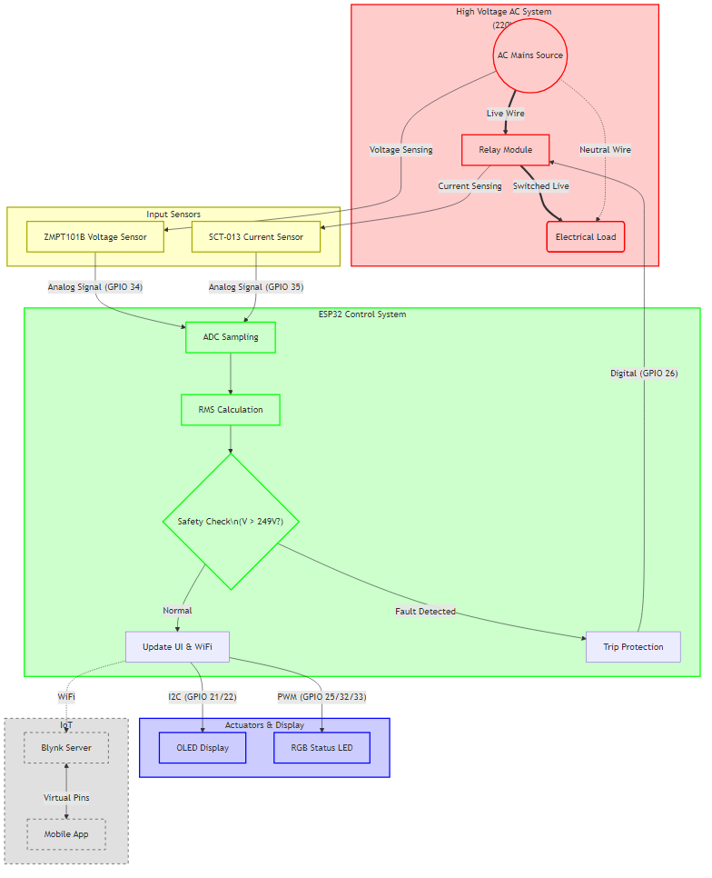
Figure 3. 1: Flowchart of the system architecture

Table 3. 1: Hardware Components specifications and Function
Component | Specification | Function
ESP32-WROOM-32 | 32-bit, 240MHz, WIFI + BT | Central Processing & Control
ZMPT101B | 2mA/2mA Ratio, Op-Amp | Voltage Attenuation & Isolation
SCT-013-100 | 100A/1v | Current Sensing (Non-invasive)
Relay Module | SRD-05VDC-SL-C, 10A/250V | Load Switching/Protection
OLED Display | SSD1306, 128x64, I2C | Data Visualization
RGB LED | 5mm, Common Cathode | Mode/Status Indication
Power Supply | 2S 3.7v Li-ion battery | System Power
Charging Module | 2S 4A | System Power charging

- Actuation and Switching: A 5V Two-channel, Electromechanical Relay Module is the main circuit breaker. The relay is rated for 10A at 250VAC. It offers an absolute physical separation between the low-power control signal and the high-power load circuit. It is motivated by a driver circuit on the module, based on a transistor, to permit the meager espresso of ESP32 to alter the inductive coil.
- User Interface: A blue OLED Display (SSD1306 128x64 pixels, 0.96-inch) with I2C protocol was selected due to high contrast and low power consumption, which allowed making the visualization of real-time information and alerts clear.
- Status LED: RGB LED placed in common cathode is used to provide immediate color-coded system status (Normal (green), Trip (red), Initialization (blue)) and uses the Pulse Width Modulation (PWM) to mix colors.
- Power Supply and Voltage Regulation: The design has a 2-cell Li-ion battery of 3.7 volts each with 4400mah charge and is capable of supplying 7.8 volts minimum and 8.6 volts maximum charge. This 7.4V is also reduced to 5V DC with a LM2596 voltage regulator (buck converter), which is a stable source of power to the ESP32. Reliable power distribution is paramount for measurement accuracy; the system requires two distinct voltage domains. The ESP32 and OLED display operate at 3.3V. The development board includes an onboard AMS1117 linear regulator to step down the 5V power supply. While the 5V Analog/Relay Domain is used by the Relay coil and ZMPT101B Op-Amps. To prevent noise from the power supply from affecting the ADC readings, filtering capacitors are placed near the sensor inputs. Furthermore, the ZMPT101B and SCT-013 biasing circuits are chosen to maximize the dynamic range of the ESP32's ADC (0–3.3V) while avoiding saturation.

System Design
The schematic design is concerned with the right impedance matching and signal conditioning.
- ADC Interfacing: ESP32 has two ADCs (ADC1 and ADC2). Because ADC2 is channeled with the Wi-Fi radio driver, Wi-Fi transmission during ADC2 use results in high levels of reading error. That is why the voltage and current sensors ADC channels were chosen with a strict selection of ADC1 (GPIO 34 and GPIO 35), respectively.
- Relay Driver: The relay was attached to GPIO26. The circuit logic is structured to make a logic LOW or HIGH, according to what state the various relay modules are to energize the coil. In the module, a flyback diode across the relay coil is intrinsic to reduce spikes in voltage during switching.
- I2C Bus: The OLED display is interconnected with the standard I2C pins, which are the GPIO 21 (SDA) and the GPIO 22 (SCL), and the pull-up resistors, internally included with the module.
All the system wiring is in accordance with the schematic diagram of Figure 3.2 and the veroboard system design in Figure 3.3, with isolation between the High Voltage (Mains) and the Low Voltage (Control) side.

System Planning
Noise mitigation and electromagnetic compatibility (EMC) were very much taken into consideration as the system is a mixed-signal system where switching devices like relays are mixed with sensitive analogue-to-digital conversion (ADC) circuits. The sensor signal wires were shortened to minimize the effect of electromagnetic interference and induced noise.

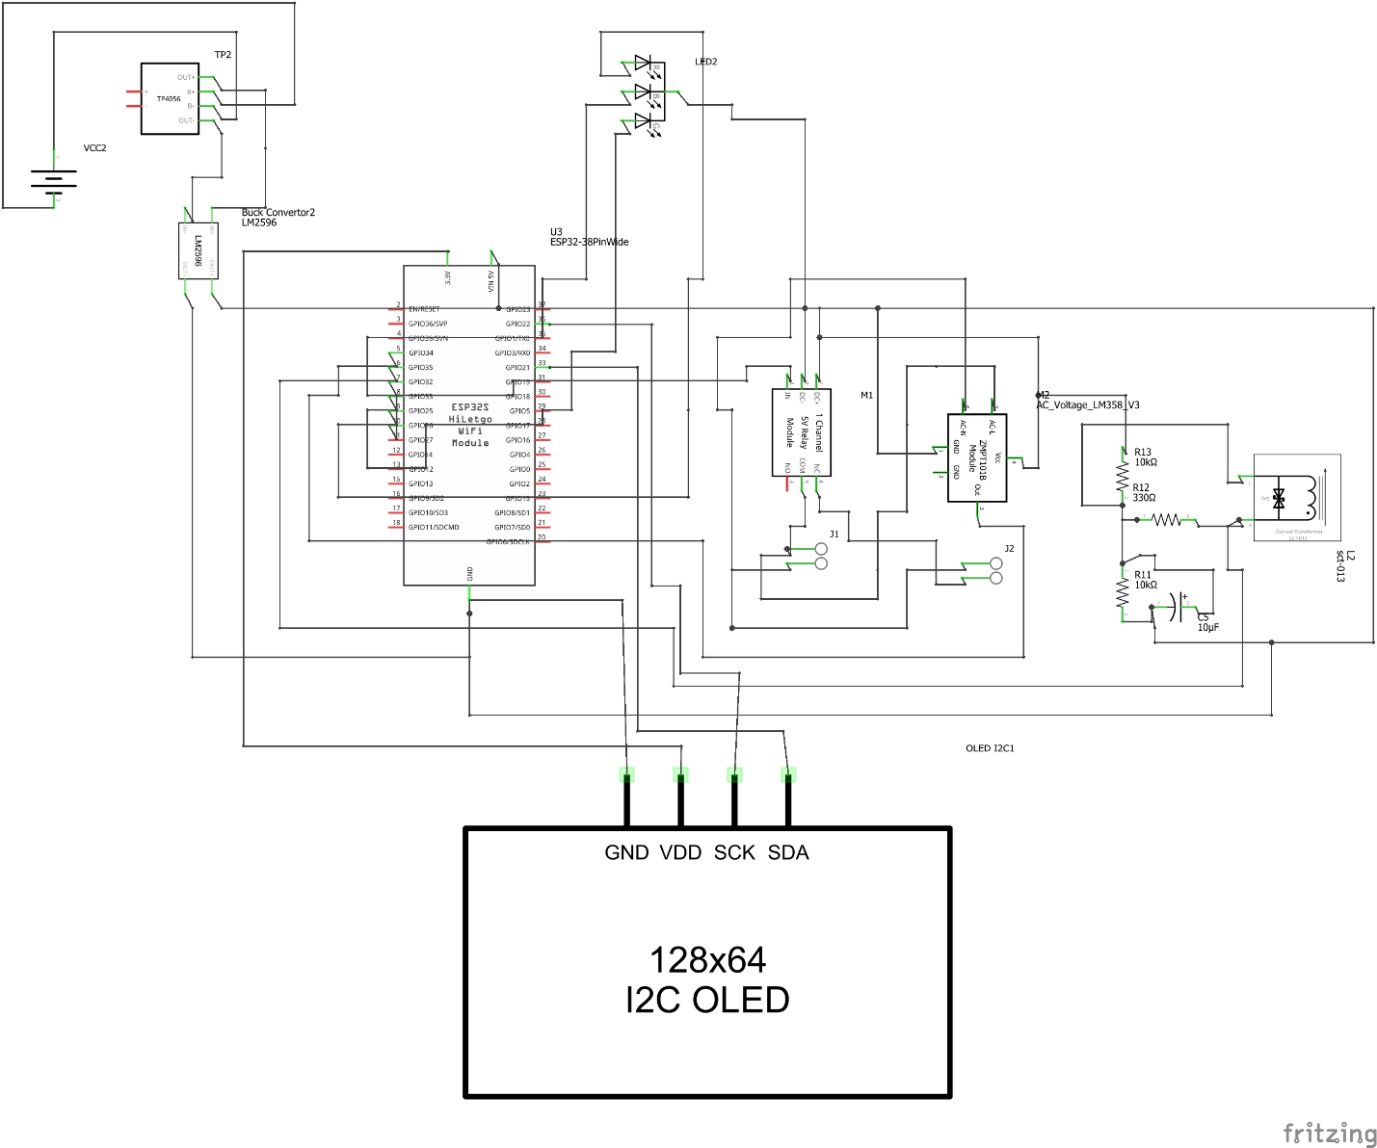
Figure 3. 2: System Schematic Diagram

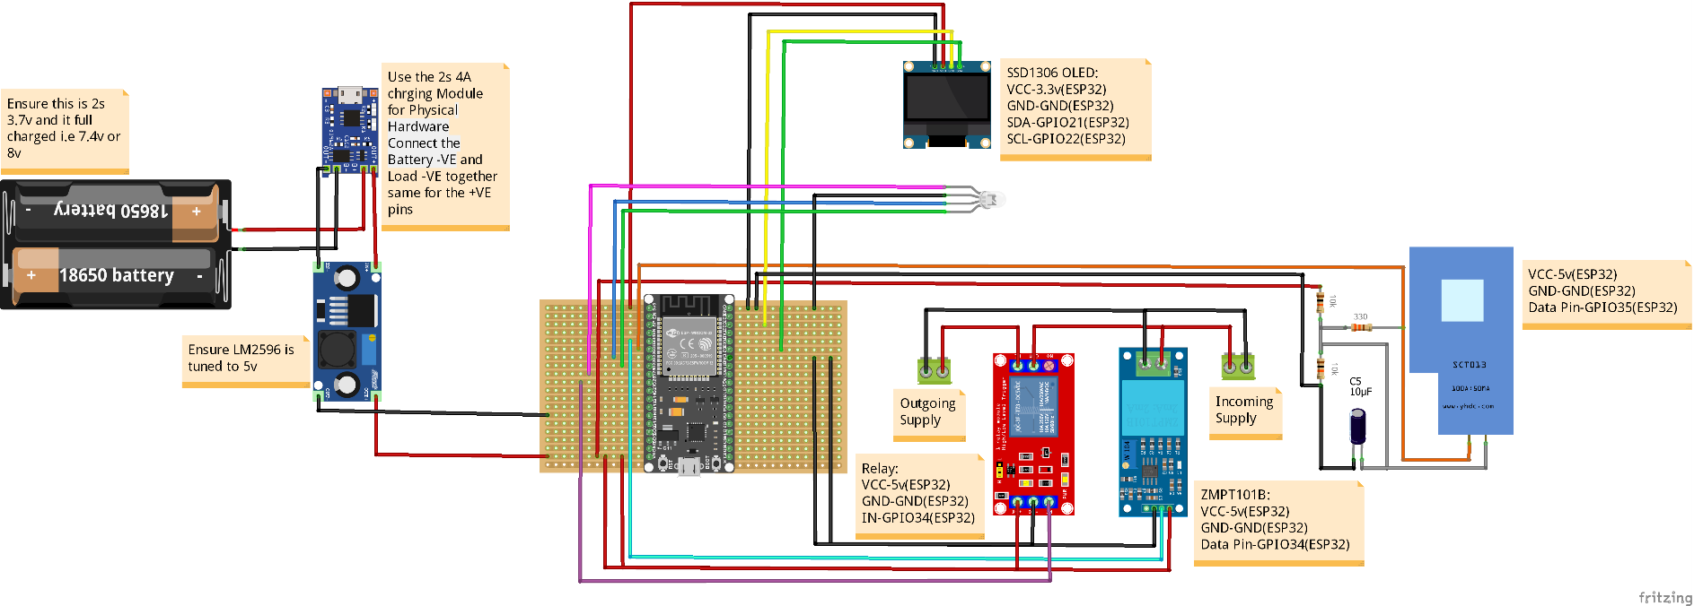
Figure 3. 3: Veroboard System Design
Along with hardware measures, software methods of signal averaging and low-pass filtering were also used to reduce sharp spikes in ADC values, which are the cause of transient spikes in ADC readings, which could cause false triggers and affect overall measurement quality.
The components of the chosen platform, such as the ESP32 microcontroller and other solid-state electronics, can be guaranteed to work well under a temperature range of 40°C to +85°C. Relay contacts, though, are prone to heat when high current loads are imposed on them. In order to avoid this risk, the design has proper ventilation and a proper choice of wire gauge as specified in American Wire Gauge (AWG) that would allow handling of current safely, and avoid overheating when the appliance has to work long hours.

IoT Integration with Blynk
The system incorporates the Blynk IoT platform to offer a strong and real-time remote monitoring and control visualization to monitor energy usage patterns and the current state of the safety mechanism, regardless of the location, with access to the internet. With this integration, users can have situational awareness of their electrical system at home even when they are not physically present, enhancing their convenience, safety, and preemptive energy consumption.
Blynk mobile dashboard is created with large visibility to provide real-time and easy feedback regarding the electrical viability of the house. One of the most important elements of the IoT integration is the System State indicator that provides real-time accessibility and control to the residential power supply. The ESP32 microcontroller handles data collection and transmission, packages sensor measurements into digital data streams, and sends them to the Blynk cloud through the local Wi-Fi network. Such logic will guarantee that data transmissions will be repeated until the successful synchronization with the dashboard is reached, which will prevent the dissemination of data, help to reduce the communication gaps, and provide the mobile interface with the proper indicators of the actual power conditions in the residence.

System Operation and Control Logic
The system firmware is a continuous, non-blocking polling loop built around a Finite State Machine (FSM) to control the different operating modes, i.e., Initialization, Normal Operation, Fault/Trip, and Wi-Fi Reconnection. This style of architecture provides deterministic behavior, effective scheduling of tasks, as well as quick reaction to the fault conditions without stopping system execution. The real-time sensor measurements, communication status, and protection logic outcome are used to govern the state transitions.

Signal Processing and RMS Calculation
It has already shown that to measure electrical parameters of alternating current (AC), the calculation of the Root Mean Square (RMS) values is necessary instead of simple values of peak or average, since the RMS values are actually the useful values of heating of voltage and current. The ESP32 measures the instant voltage and current waveforms at a frequency much greater than the Nyquist frequency compared to the mains frequency (50/60 Hz). Instantaneous acquired and processed values (v_{i}, i_{i}) are obtained over a specified sampling window, usually 200 ms, which is a few mains cycles, about 10-20 mains cycles. To remove the dependency on the sign, each of the samples is squared, and then the squared values are summed up and averaged with the number of samples, N. The square root of the mean of the squared samples will then yield the values of the RMS as expressed by equations 3.1-3.2:
$V_{RMS}=\sqrt{\frac{1}{N}\sum_{n=0}^{N-1}{v^{2}\left[n\right]}}$ (3.1)
$I_{RMS}=\sqrt{\frac{1}{N}\sum_{n=0}^{N-1}{i^{2}\left[n\right]}}$ (3.2)
These computations are implemented using the EmonLib library, which also uses digital high-pass filtering to eliminate any DC offset caused by sensor biasing and signal conditioning circuits to enhance the accuracy and stability of measurements.

Protection Logic
The protection logic is the first-priority task of the firmware, and it works by continually comparing the calculated values of RMS against pre-established safety levels. The state of over-voltage is identified by equation 3.3, whereas the under-voltage condition is identified by equation 3.4. Equally, an over-current fault is activated when the RMS value of current exceeds the Maximum current, as illustrated in equation 3.5. When any of these fault conditions are detected, the system instantly goes into the TRIPPED state, whereby the relay is de-energized to isolate the load electrically, the RGB status indicator changes to red, and a fault message is sent to the cloud platform. The hysteresis bands are used in the software to make sure that the relay does not oscillate fast when the measured values approach the specified thresholds, and thereby the switching components work with great stability and can last longer.
$V_{RMS}>V_{MAX}$ (3.3)
$V_{RMS}>V_{MIN}$ (3.4)
$I_{RMS}>I_{MAX}$ (3.5)

Load and Power Calculations
Theoretical power calculations are used to determine a clear correlation between the electrical parameters that the system measures and help make safe protection choices. In alternating current (AC) circuits, apparent power S, which is the total power capacity required by the load and supplied by the source, is defined as the product of the root mean square (RMS) voltage and the root mean square (RMS) current of both the source and the load. This association is shown in equation 3.6.
$S_{\left(VA\right)}=V_{RMS}×I_{RMS}$ (3.6)
Apparent power is particularly important in protection and system sizing because it reflects the total electrical stress placed on conductors, switching devices, and protective elements, regardless of how efficiently the power is converted into useful work.
When the load is purely resistive, like a heating element or an incandescent lamp, the power factor is equal to unity equation 3.7, and it follows that the apparent power is identical to the active (real) power, P. But in the case of inductive loads or reactive loads, the effective power delivered to the load is less, and this is provided by equation 3.8.
$\cos{∅}=1$ (3.7)
$P=V_{RMS}×I_{RMS}×\cos{∅}$ (3.8)
where ϕ is the phase angle between the voltage and current waveforms. In the modern system operational, apparent power is taken as the main tool because it provides a more conservative and safer starting point to estimate conductor rating, circuit breaker choice, and general wiring protective methods to safeguard an environment where there are unknown or varying load power factors. To further improve the level of operational safety, a margin is added to the over-current protection mechanism by the use of a 1.25 safety factor, which is equivalent to 25% margin on the maximum allowable conductor rating. This is to make sure that precautionary measure is taken before the thermal precautions of the wiring are surpassed. As an illustration, when a conductor has a maximum current of 40A, the trip current is determined by:
$I_{TRIP}= \frac{I_{RATED}}{1.25}= \frac{40 A}{1.25}=32A$ (3.9)
This method of conservation enhances the reliability of the system, minimizes the possibility of degradation of insulation or occurrence of fires, and the protection mechanism should act preemptively in case of abnormality or overload.

Performance Metrics and Evaluation
To prove the efficiency, reliability, and accuracy of the suggested system scientifically, a list of clearly defined performance measures and assessment criteria was developed. These metrics were selected to assess not only the correctness of electrical measurements but also the responsiveness of the protection mechanism, communication reliability, and overall system robustness under both normal and fault conditions.

Measurement Accuracy
The accuracy of measurement was obtained by comparing the voltage and current readings of the system to the readings measured on a calibrated reference instrument. A digital multimeter with a known accuracy specification was taken as the benchmark. The measurement error was calculated by taking the absolute difference between the measured value and the reference value and dividing it by the same reference value as a percentage. This is expressed as equation 3.10.
$Error(\%)=\left|\frac{X_{measured}-X_{reference}}{X_{reference}}\right| ×100$ (3.10)
where X represents either voltage or current. This metric is a quantitative method to determine sensor accuracy and calibration performance, where less error results is an improved system performance.

Trip Response Time (Latency)
Trip response time, also known as system latency, is the time that describes the delay between the identification of a fault condition and the actual physical opening of relay contacts. This parameter plays a paramount role in the safety-related applications because the lower the response time, the lower the chances of damage to equipment and electrical hazards. The measurements of response time were achieved with the induction of fault conditions and by measuring the delay between the threshold violation and the de-energization of the relay. These are the aggregate effects of signal processing, decision logic in the firmware, and electromechanical relay actuation.

System Testing and Validation Procedure
The system testing was structured in such a way that it tested the system performance at all possible states of operation, including component behavior. First, the unit test was done on a bench level, where each sensor was tested separately with a low-voltage source. This stage tested the voltage and current conversion ratios, sensor interfacing, and signal conditioning circuit correctness. After unit testing, a calibration stage was carried out with a known resistive load, a 10 W energy bulb load connected to a single socket of 140 W, with a calibrated digital multimeter. At this level, software calibration coefficients (voltage and current scaling factors (slopes)) were adapted to reduce the percentage error of measurement and enhance the overall accuracy.
Integration testing carried out fault simulation intentionally in order to test the protection logic. A variable autotransformer (V_{ariac}) was used, which enabled the voltage of the input AC to be adjusted, and was used to introduce voltage-related faults, between 0 V and 270 V. This was done to confirm the proper activation of under-voltage and over-voltage protection limits. Long-term reliability was tested by subjecting a continuous operation test to the system under nominal load between 24 and 48 hours. This test was aimed at revealing possible thermal concerns, memory leakage in the firmware, or wear and tear of relays, or Wi-Fi disconnection, and therefore, give an idea of how stable the system could be when used over an extended period.

